Tetris Design Document

Overview

This program is for entertainment. It will be controlled by a keyboard, specifically the left and right arrow keys, the x key, the c key and the space bar. The program will be able to use the left and right arrow keys and the space bar for movement, the x and c key for rotation, and will increase the user’s score each time a condition is met (in the case of tetris, each time a horizontal line is filled). The program has the capability to take user input and respond in real time with images. This program can only be played by 1 player at a time.

Diagrams

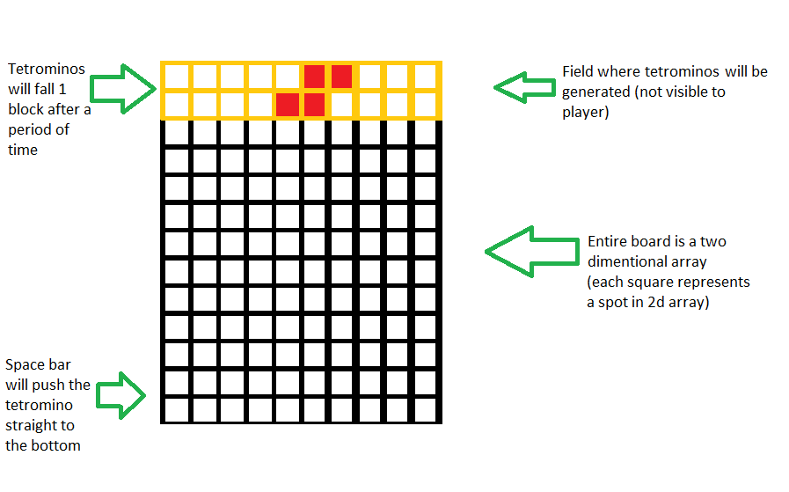

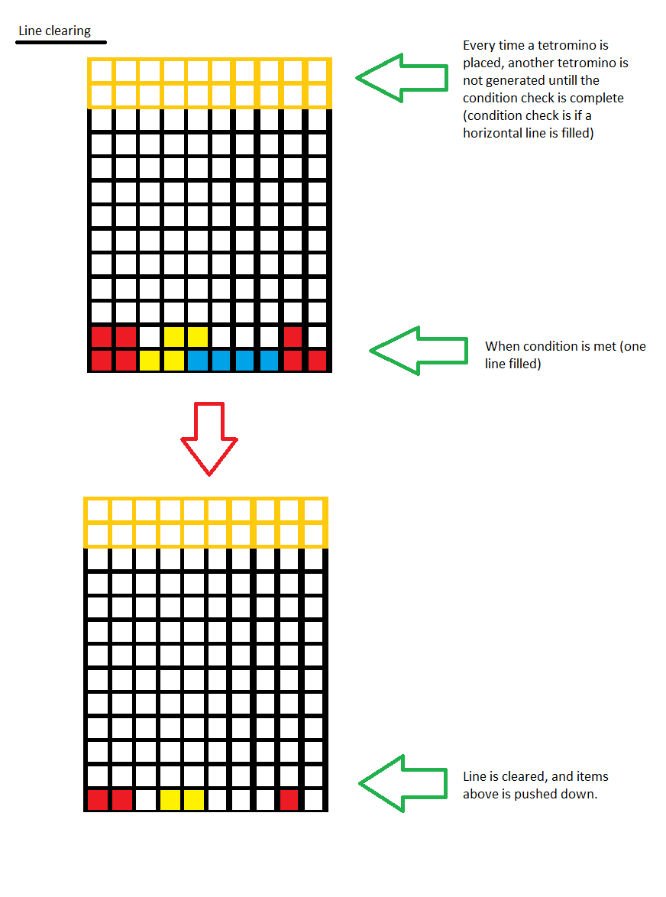

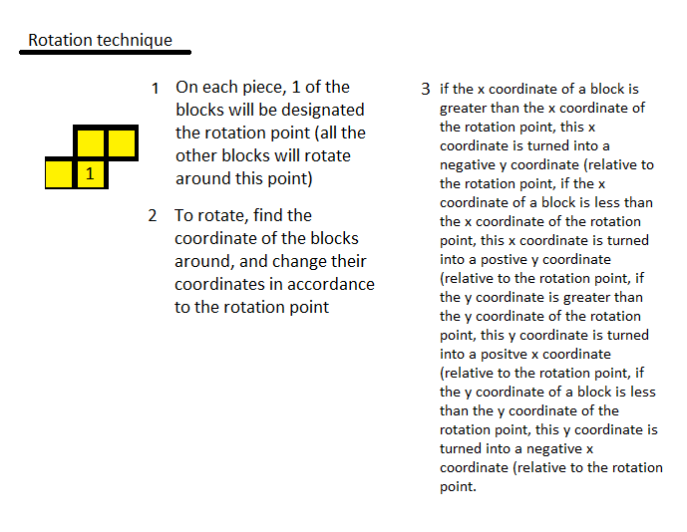

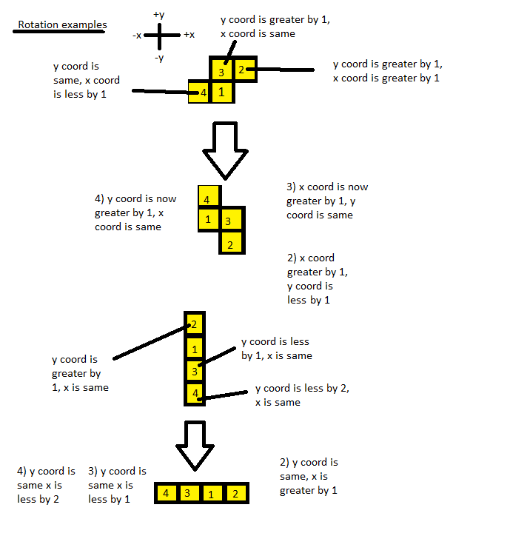

Top down design

For this program a method needs to be written for rotation of the piece clockwise, rotation of the piece counterclockwise, line clearing, hard dropping (putting the tetromino piece straight to the bottom), piece generation, losing the game, drawing the board, and for keypresses. The clockwise rotation method will rotate the piece 90 degrees clockwise and will take a 2 dimensional integer array and return void. The counterclockwise rotation method will rotate the piece 90 degrees counterclockwise and will take a 2 dimensional integer array and return void. The line clearing method will check if any horizontal section of the board is filled, and if so, it will clear that line, push above lines downward, and return the number of lines cleared multiplied by 1000, thus it will take an 2 dimensional integer array and return an integer. The hard dropping method will push the tetromino to the furthest position near the bottom without overlapping any already filled positions and will take a 2 dimensional integer array and return void. The piece generation method will generate a random tetromino piece at the top of the board, and will take no parameters and return void. The losing the game method will check if any of the blocks in the top two rows in the 2 dimensional array for the board has been filled, and will take a 2 dimensional array and return a boolean. The drawing method will run whenever time passes or a keypress event occurs and it takes a 2 dimensional integer array, an integer, and returns void. The keypressed method will bridge the user’s input to the program, and it will take a keypress event and return void.

Pseudocode

(I’m not very sure how repeating code after durations of time works with hsafx, also I did multiple classes as main method has little to no code as methods such as keypress and time do not need to be directly invoked)

Time class (repeats after a certain period of time){

Declare a static two dimensional array for coordinates of the current tetromino

Run method (repeats after a certain period of time){

If one of the coordinates of the tetromino is already the lowest it can be{

Put those coordinates into the board

Run line clearing method (parameter the 2d board) and add its return to the score

Run the losing the game method (parameter the 2d board) and if it returns true, end the game

Generate new tetromino using random number generator and the static int two dimensional array for coordinates of the 7 types of tetrominoes

Put these new coordinates into the two dimensional array for coordinates of the current tetromino

}

Push the tetromino 1 block down

Redraw the board

}

}

Main class{

Declare a static integer for score

Declare a static two dimensional array for the board

Declare a static one dimensional array for the lowest points in the array which is not yet filled

Declare and assign a static final two dimensional array for coordinates of the 7 types of tetrominoes

Main method{

Declaring time and timertask object

Using timer.schedule to repeat a section

Generate first tetromino using random number generator and static final two dimensional array for coordinates of the 7 types of tetrominoes

Put these new coordinates into the two dimensional array for coordinates of the current tetromino

Draw the board

}

Drawing method{

Draws the board out and the score on the hsafx console

}

Keypressed method{

If the space bar was pressed{

Hard drop method

}

If the right arrow key was pressed{

Change coordinates in static two dimensional array (for coordinates of the current tetromino) to move tetromino right

}

If the left arrow key was pressed{

Change coordinates in static two dimensional array (for coordinates of the current tetromino) to move tetromino left

}

If the x key was pressed{

Counter clockwise rotation method

}

If the y key was pressed{

Clockwise rotation method

}

Redraw the board

}

}